Private and confidential – Application for Voluntary Board Membership

Introduction

We are delighted you’re interested in becoming a member of our Board.

If you would like to find out more about this please contact our Business Support Team who can provide more information business@horizonhousing.org

If you would like to apply, please complete the attached form which summarises the reasons for your interest in Horizon, your experience and skills. We will then have an opportunity to talk to you further about these during an interview.

Please could you read the Board Member role and job description alongside this application as we’ll want to talk to you about this in more detail if you are asked for an interview. If you’d like more information about Horizon, please visit our website www.horizonhousing.org.

Your contact details
Name (surname, forename, title):

Home address:

Email address:

Telephone numbers:
Mobile:
Home:
Work:
Where did you hear that Horizon HA is looking to appoint additional Board members?

Related interests
Are you already a shareholder of Horizon HA?

Are you a tenant of Horizon HA?

Are you related to any member of staff or Board member of Horizon HA or to any staff or Board members of Link Group and its subsidiaries?

Do you have any business or other interests which have the potential to represent a conflict of interest with the role of Board member? (if yes, please give details)

Are you a non-executive Board member of a Public, Voluntary or Community Organisation? (if yes, please list below the organisations and positions held)

Do you have a specific interest in a particular area of Horizon HA business?

Suitability for the role of a board member
From your working or personal life, could you answer the questions below to show how your skills and knowledge can meet the requirements of the role. We’re not specifically asking you to list your employment and voluntary experience, but you can refer to these where you feel it is relevant.
Can you tell us why you would like to become a member of the Horizon Board?

Please share your experiences of working as part of a team and if you have worked in a team with executive (e.g. senior staff) and non-executive (e.g. Board) members.

We have included some ‘desirable’ skills, experience and competencies’ in the job description, so could you share with us your particular skills, knowledge and experience which would suit being a member of our Board?
Availability for the role of board member
Can you confirm you would have the time and availability to be a board member?
Please add any other comments
Please add any other comments or queries you may have.

Declaration
I declare that the information I have given in this form is correct. I have not been convicted of any criminal offence (which in accordance with the Rehabilitation of Offenders Act 1974 relates only to convictions defined as ‘unspent’), I am not declared bankrupt under Bankruptcy (Scotland) Act 1985 and I have not previously been removed from the governing body of any other Registered Social Landlord.
I understand I would receive no payments as a Board Member other than out of pocket expenses.
Signed:
Date:

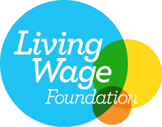
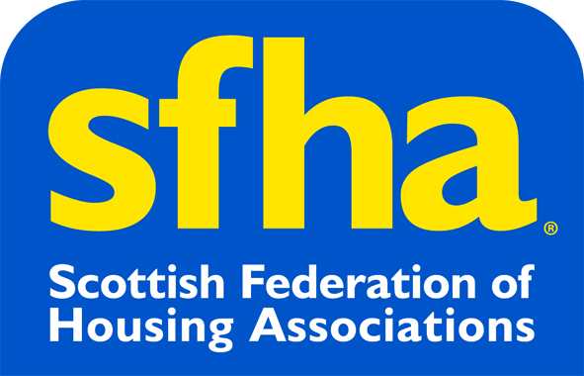
Horizon Housing Association Limited is a registered society under the Co-operative and Community Benefit Societies Act 2014, Registered Number: 1827 R(S), Registered Office: Leving House, Fairbairn Place, Livingston, EH54 6TN. It is a Charity registered in Scotland, Charity Number: SC011534; a Registered Social Landlord with the Scottish Housing Regulator, Registration Number: HAL 128; and registered as a Property Factor Id: PF000385. Part of the (c) Link group 2017.

